**N.ANJALI**

**192324137**

**SECTION 4 1**

package hello;

public class helloworld {

public static void main(String[] args) {

System.*out*.println("hello world");

}

}

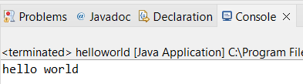

**SECTION 4 2**

**package** student;

**import** java.util.*;

**public** **class** Student {

**public** **static** **void** main(String[] args) {

Scanner scanner = **new** Scanner(System.***in***);

System.***out***.print("Enter student's name: ");

String name = scanner.nextLine();

System.***out***.print("Enter student's roll number: ");

**int** rollNumber = scanner.nextInt();

System.***out***.print("Enter student's age: ");

**int** age = scanner.nextInt();

System.***out***.print("Enter student's grade: ");

String grade = scanner.next();

System.***out***.println("\nStudent Details:");

System.***out***.println("Name: " + name);

System.***out***.println("Roll Number: " + rollNumber);

System.***out***.println("Age: " + age);

System.***out***.println("Grade: " + grade);

scanner.close();

}

}

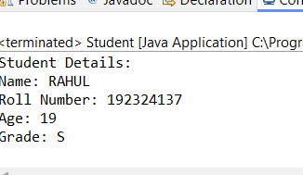

**SECTION 4 3**

**package** triangle;

**import** java.util.Scanner;

**public** **class** Triangle {

**public** **static** **void** main(String[] args) {

Scanner scanner = **new** Scanner(System.***in***);

System.***out***.print("Enter the base of the triangle: ");

**double** base = scanner.nextDouble();

System.***out***.print("Enter the height of the triangle: ");

**double** height = scanner.nextDouble();

**double** area = *calculateArea*(base, height);

System.***out***.println("The area of the triangle is: " + area);

}

**public** **static** **double** calculateArea(**double** base, **double** height) {

**return** 0.5 * base * height;

}

}

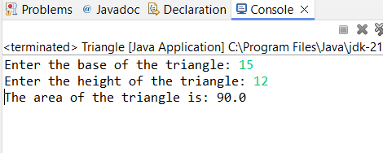

**package** formulas;

**import** java.lang.Math;

**public** **class** Fromulas {

**public** **static** **void** main(String[] args) {

**double** x = 10.0; // assume x is initialized

**double** y = 5.0; // assume y is initialized

**double** z = 3.0; // assume z is initialized

**double** a = *formulaA*(x);

**double** b = *formulaB*(x, y);

**double** c = *formulaC*(z, x);

**double** d = *formulaD*(x, y);

**double** e = *formulaE*(x, y);

**double** f = *formulaF*(x);

System.***out***.println("a = " + a);

System.***out***.println("b = " + b);

System.***out***.println("c = " + c);

System.***out***.println("d = " + d);

System.***out***.println("e = " + e);

System.***out***.println("f = " + f);

}

**public** **static** **double** formulaA(**double** x) {

**return** Math.*sqrt*(Math.*pow*(x, 5) - 6 / 4);

}

**public** **static** **double** formulaB(**double** x, **double** y) {

**return** x * y - 6 * x;

}

**public** **static** **double** formulaC(**double** z, **double** x) {

**return** 4 * Math.*cos*(Math.***PI*** / 5) - Math.*sin*(Math.***PI*** * Math.*pow*(x, 2));

}

**public** **static** **double** formulaD(**double** x, **double** y) {

**return** Math.*pow*(x, 4) - Math.*sqrt*(6 * x - Math.*pow*(y, 3));

}

**public** **static** **double** formulaE(**double** x, **double** y) {

**return** 1 / (y - 1) / (x - 2 * y);

}

**public** **static** **double** formulaF(**double** x) {

**return** 7 * Math.*cos*(Math.***PI*** * (Math.*sqrt*(5) - Math.*sin*(Math.*sqrt*(3 * x - 4))));

}

}

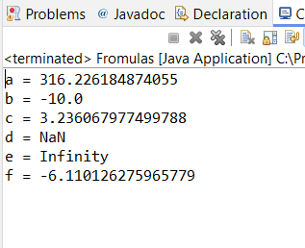

**package** booleans;

**import** java.util.Scanner;

**public** **class** Booleans {

**public** **static** **void** main(String[] args) {

Scanner scanner = **new** Scanner(System.***in***);

System.***out***.print("Enter a value for i: ");

**int** i = scanner.nextInt();

System.***out***.print("Enter a value for j: ");

**int** j = scanner.nextInt();

**boolean** true_false;

true_false = (j < 5);

System.***out***.println("(j < 5) = " + true_false);

true_false = (j > 3);

System.***out***.println("(j > 3) = " + true_false);

true_false = (j < i);

System.***out***.println("(j < i) = " + true_false);

true_false = (i < 5);

System.***out***.println("(i < 5) = " + true_false);

true_false = (j <= 5);

System.***out***.println("(j <= 5) = " + true_false);

true_false = (6 < 6);

System.***out***.println("(6 < 6) = " + true_false);

true_false = (i!= j);

System.***out***.println("(i!= j) = " + true_false);

true_false = (i == j || i < 50);

System.***out***.println("(i == j || i < 50) = " + true_false);

true_false = (i == j && i < 50);

System.***out***.println("(i == j && i < 50) = " + true_false);

true_false = (i > j || true_false && j >= 4);

System.***out***.println("(i > j || true_false && j >= 4) = " + true_false);

true_false = (!(i < 2 && j == 5));

System.***out***.println("(i < 2 && j == 5)) = " + true_false);

true_false =!true_false;

System.***out***.println("!true_false = " + true_false);

}

}

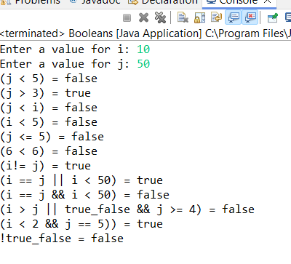

**SECTION 4 4**

**package** mystring;

**public** **class** Mystring {

**public** **static** **void** main(String[] args) {

String myString1 = "abc";

System.***out***.println("Method 1: " + myString1);

String myString2 = **new** String("abc");

System.***out***.println("Method 2: " + myString2);

String myString3 = String.*valueOf*("abc");

System.***out***.println("Method 3: " + myString3);

}

}

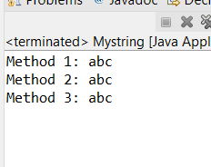

**package** stringcompare;

**public** **class** Stringcompare {

**public** **static** **void** main(String[] args) {

String s1 = "ABC";

String s2 = **new** String("DEF");

String s3 = "AB" + "C";

System.***out***.println("a. s1.compareTo(s2): " + s1.compareTo(s2));

System.***out***.println("b. s2.equals(s3): " + s2.equals(s3));

System.***out***.println("c. s3 == s1: " + (s3 == s1));

System.***out***.println("d. s2.compareTo(s3): " + s2.compareTo(s3));

System.***out***.println("e. s3.equals(s1): " + s3.equals(s1));

}

}

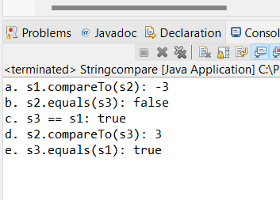

**package** concantation;

**public** **class** Strconcantation {

**public** **static** **void** main(String[] args) {

// Declare and instantiate two separate String objects

String str1 = "Hello";

String str2 = "World";

// Concatenate them together and assign to a third String object

String str3 = str1 + " " + str2;

// Print the result

System.***out***.println("str1: " + str1);

System.***out***.println("str2: " + str2);

System.***out***.println("str3: " + str3);

}

}

